Dive Manager
Table Of Contents
1. Dive Manager Overview
2. What Dive Manager used for
3. Core Dive Manager Concepts
4. Dive Manager Tutorial
5. Technical requirement

1. Dive Manager Overview

Dive Manager is user for the Administration and Management of services.

2. What Dive Manager used for

Using this application we can

- Dashboard – Display Grafana Graphs
- Resource Management
- Predictive Models - Predictive Modelling using Open Scoring-Engine – a PMML approach
- Lamda Models - Publish a machine learning engine to the web as a service using Apache PredictionIO
- Manage LDAP User
- Schedule Job

3. Core Dive Manager Concepts
Dive Manager is developed using Spring Web MVC framework.
- Spring’s web MVC framework is, like many other web MVC frameworks, request-driven, designed around a central Servlet that dispatches requests to controllers and offers other functionality that facilitates the development of web applications.
- Spring’s DispatcherServlet however, does more than just that.
- It is completely integrated with the Spring IOC container and as such allows you to use every other feature that Spring has.
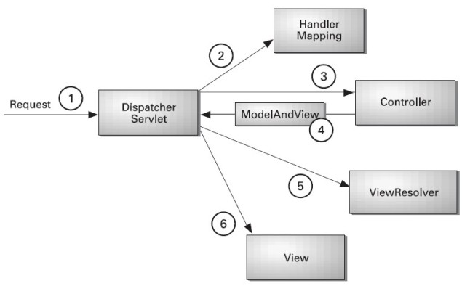
Figure 3.1. The request processing workflow in Spring Web MVC (high level)
- As displayed in the figure, all the incoming request is intercepted by the DispatcherServlet that works as the front controller.
- The DispatcherServlet gets entry of handler mapping from the xml file and forwards the request to the controller.
- The controller returns an object of ModelAndView.
- The DispatcherServlet checks the entry of view resolver in the xml file and invokes the specified view component.

4. Dive Manager Tutorial
Dive manager is integrated with LDAP login. After we login we get the page where we can view the Models published, Scheduler List and Web service assigned to User List. It is used for management below tasks.
- Dashboard
- Resource Management
- Predictive Models
- Jobs
- Lambda Models
- User

Dashboard

After logging in Dive Manager Dashboard page is displayed shown below. It contains system details, show Grafana graphs and Displays docker containers services and Images.

Resources
Using Dive Manager we can Set up your Docker environment. We can manage the docker container,service and images.

Services

When you create a service, you specify which container image to use and which commands to execute inside running containers.
You also define options for the service including:
the port where the swarm makes the service available outside the swarm an overlay network for the service to connect to other services in the swarm CPU and memory limits and reservations a rolling update policy the number of replicas of the image to run in the swarm

Below screen in dive manager how the services displayed and created.

Clicking on Add disaplya below page. We need to enter all mandatory fields and Service would be created. We can remove service which is not required by clicking on Remove button

Containers
We can create Docker Container using dive manager

Images.
Dive Manager displays all the images created by docker. But this version we can not do any management with Images.
Below is the view of Images in Dive Manager.

Technical requirement

5. 1 Client requirement

As Dive Manager is a web application it could be run on most of custom operating systems via a web browser. We tested PATH with Chrome 1.0 and IE 7.0 and found no problem.

5.2 Server Requirement

The following technologies are required for Dive Manager server.

- Mysql 5.1
- Java 1.7
- Tomcat 5

